Data Structures and Algorithms
Assignment 3

Question 1
.
- Write a pseudo code algorithm to Implement a Stack using Queue(s)
- Describe how the pseudo code algorithm works. You may use suitable diagram(s) to answer the question
- Convert the above pseudo-code into c code.
- Prove the validity of your program using test data and test results

Question 2
Describe how the following set of operations work on the code written by you above question 1. You may use a suitable diagram to illustrate the answer.

- Push(‘a’)
- Push(‘b’)
- Push(‘c’)
- Pop
- Push(‘d’)
- Pop
- Pop
- Pop
- Push(‘e’)

Question 3

  - Write a pseudo code algorithm to reverse a set of numbers stored in a queue(s).
  - Note: You may use a stack as an intermediate container.
- Convert the above pseudo code algorithm into a C program
- Using the above C program written by you, generate the following outputs using the given inputs.

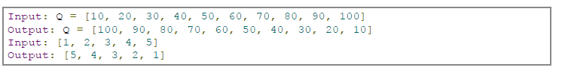

Question 4

Given an efficient circular array-based queue (Q) capable of holding 10 objects.
Show the final contents of the Q after the following code segment is executed

Int k
for (k = 1; k ≤ 7; k++)
{
Q.enqueue(k);
}
for ( k = 1; k ≤ 7; k++)
{
Q.enqueue(Q.dequeue());
}

Question 5

Consider the following Pseudo Algorithm.

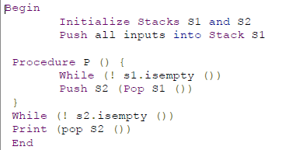

- What is the pseudo code above intended to do?
  - b) If the following values were inserted into the above pseudo code, what would be the final output? Values are: 34, 12,18,23,55,11,9

  - Question 6

- Write a pseudo code algorithm and c program to generate binary numbers between 0 to n using a queue

For example, for N=10, the Binary numbers are



